**Passing the Torch: Quest for the Heir to Sergio Busquets**

By: Mingyang Li, Junying Li, Haoji Wang, Yuhan Xie

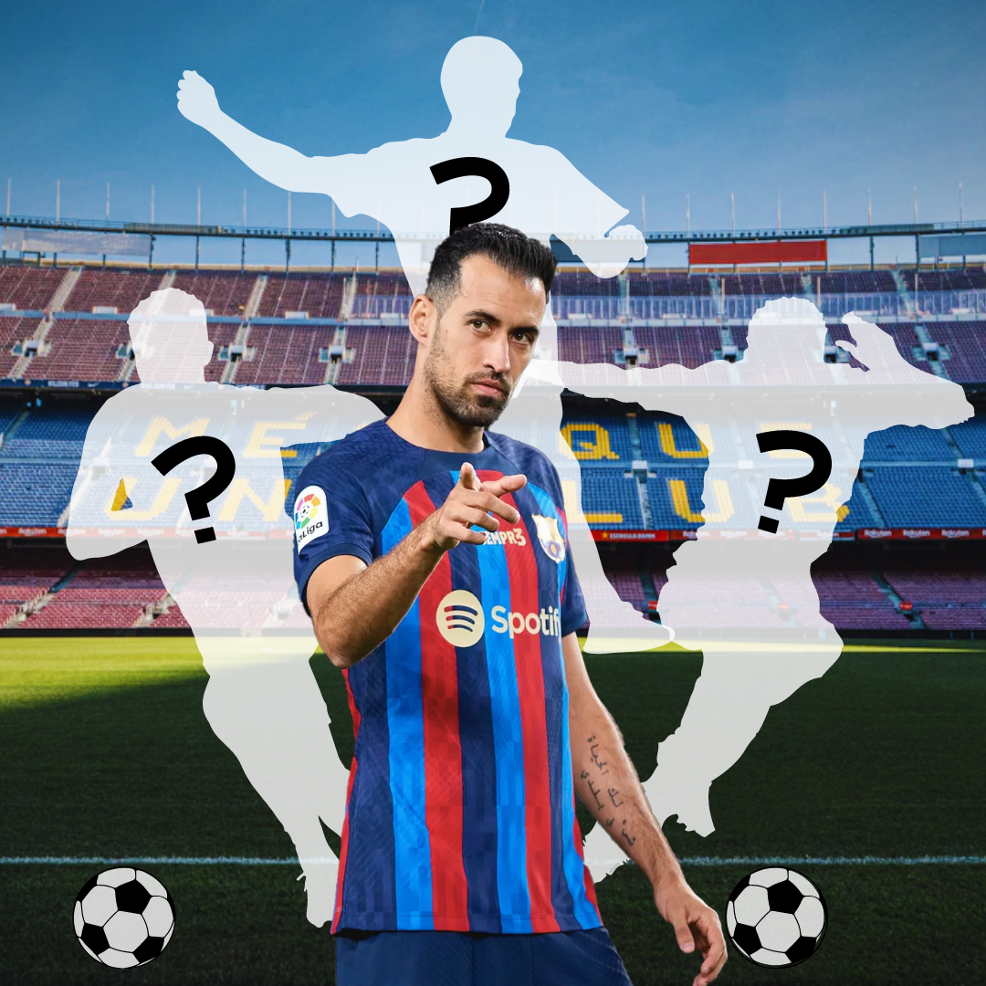

**Introduction**

Spanish National Team head coach Vicente Del Bosque once claimed, “You watch the game, you don’t see Busquets. You watch Busquets, you see the whole game.” This quote perfectly encapsulates Sergio Busquets as a football player – the master of simplicity. Unlike typical defensive midfielders, he lacks the tenacity of N'golo Kante and the physicality of Federico Valverde, but he compensates for it with his elite footballing intelligence by thinking several steps ahead of his opponents. No matter how tricky the situation, he always finds the optimal solution, be it one short pass to a teammate in space, or an elegant half-turn to evade incoming opponents. Even in defense, his elite positioning makes up for his lack of pace, as he cleverly anticipates the opponent’s next move before nipping dangerous counter-attacks in the bud with a well-timed interception or tackle. Such innate flair and grace is exactly why Sergio Busquets has been hailed as one of the best defensive midfielders of all time.

Sergio Busquets’ illustrious career commenced in 2008 when he broke into Pep Guardiola’s world-conquering Barcelona team as a promising 20-year-old talent. Since then, he has grown to become one of the most pivotal anchors of both Barcelona and the Spanish National Team. Forming an invincible midfield triumvirate with Xavi Hernandez and Andres Iniesta, they swept up countless number of trophies along the way, including 3 Champions Leagues, 9 La Ligas, 2 European Championships, and 1 World Cup. Sadly, every tale has its final chapter. After lifting his final La Liga trophy last season as the captain of Barcelona, he left his boyhood club to join Inter Miami in Major League Soccer.

Lamentably, Sergio Busquets never received the accolades that he truly deserves, perhaps due to his simplistic playing style. In fact, towards the end of his Barcelona career, he often became the scapegoat for Barcelona’s shambolic defensive performances due to his deteriorating pace. Yet, Busquets’ indispensable worth finally became apparent this season. Without him this season, Barcelona has conceded the same amount of goals as last season in half the number of games. Barcelona has especially struggled in transition defense against counter-attacking teams, as well as building out from the back, both of which are Busquets’ areas of expertise. Hence, the Barcelona management has been scrambling in the transfer market hoping to find a world-class defensive midfielder, but tight finances and a lack of quality replacements have hampered their progress. Therefore, in this article, we will first analyze the importance of Busquets to Barcelona, before identifying similar players among midfielders in the top 5 European Leagues who can potentially serve as an ideal replacement for Busquets in the current Barcelona team.

**Key Terms and Metrics**

In football, midfielders serve as the vital bridge between attack and defense. Not only must they excel in progressing the ball up the pitch, they must also act as the shield in front of their team’s defensive line. This entails disrupting the opponent's buildup play through well-timed tackles, vigilant tracking of opponents’ movements, and proactive closing down of space. Therefore, in our analysis of Sergio Busquets and other midfielders, we evaluate their abilities based on 6 skill categories, each supported by carefully selected metrics from FBref. These metrics are chosen to best represent the specific attributes of each category, as detailed in the table below. The first 3 categories focus on ball progression, while the last 3 focus on defense and regaining possession.

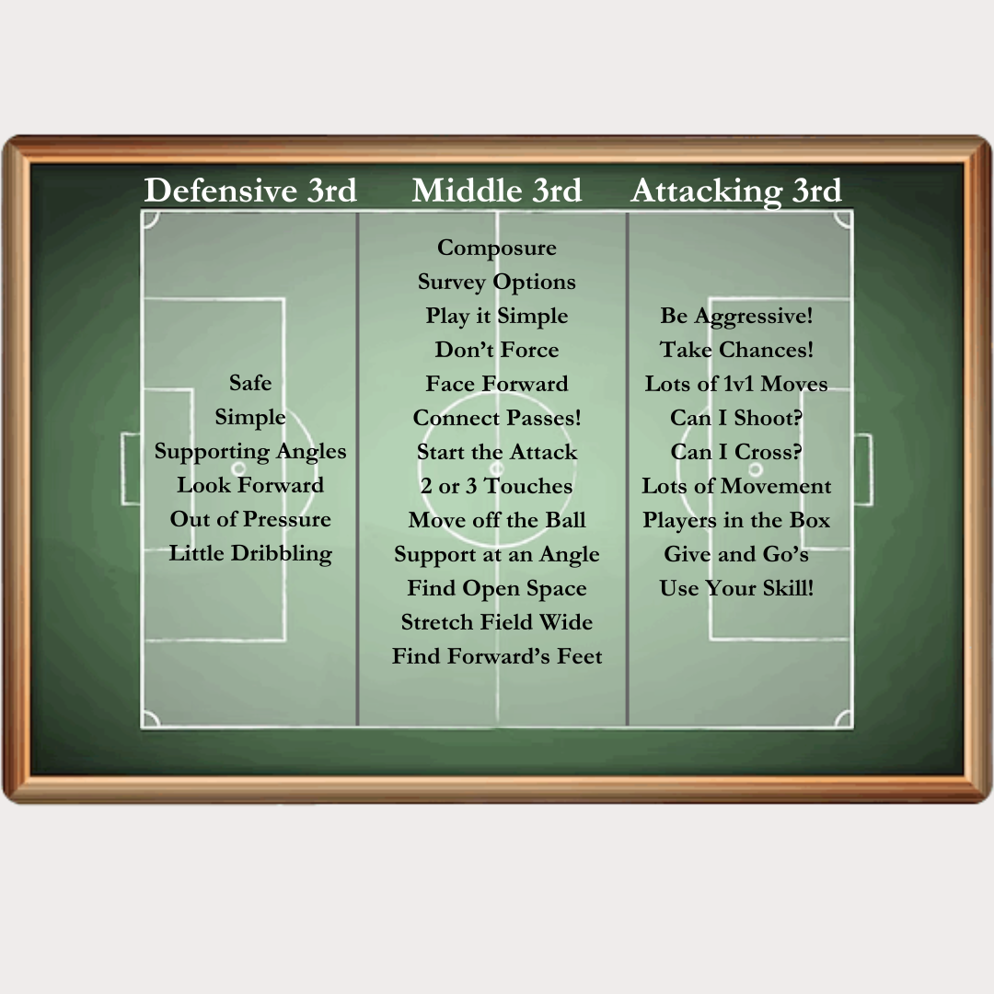

Playing Thirds in Football [Source: SportSessionPlanner]

| **Skill Category** | **Definition** | **Metrics Used** |
| --- | --- | --- |
| **P1:** Defensive 3rd Progression | Player’s ability to progress the ball from the defensive 3rd to the middle 3rd, also known as “**playing out from the back**”. Players should be able to receive the ball with their back to goal, retain the ball under pressure, and complete passes consistently. Play with **caution**. | 1. Total passes completed 2. Pass completion rate 3. Number of miscontrols 4. Touches in defensive penalty area 5. Touches in defensive third |
| **P2:** Middle 3rd Progression | Player’s ability to progress the ball from the middle 3rd to the attacking 3rd. While keeping possession, players should also seek chances to **break into opposition territory** via **passes** or **carries**.  Requires a delicate balance between caution and creativity. | 1. Progressive carries 2. Progressive passes 3. Passes into final third 4. Number of times dispossessed 5. Touches in middle third |
| **P3:** Attacking 3rd Progression | Player’s ability to turn possession into **scoring chances**. Unlock opposition defense with killer passes, find teammates in shooting positions, move into dangerous positions and score goals. Requires **creativity** and quick reactions to seize opportunities. | 1. Non-penalty expected goals + assisted goals 2. Key passes 3. Shot-creating actions 4. Goal-creating actions 5. Passes into penalty area 6. Touches in attacking third |
| **D1:** Transition Defence | Player’s ability to defend against swift **transitions** and counter-attacks. Requires elite **positioning**, astute understanding of time and space, and fast anticipation of opponents’ movements. | 1. Number of dribblers tackled 2. Percentage of dribblers tackled 3. Number of passes blocked |
| **D2:** Ball-Winning | Responsibilities include covering expansive areas of the field effectively: **pressing** opponents, making **tackles**, and consistently regaining possession in middle 3rd. Enhance defensive stability by prevailing in midfield duels. | 1. Tackles 2. Tackles won 3. Interceptions |
| **D3:** High Press | Aims to **swiftly regain possession** of the ball by exerting pressure in the opponent’s defensive zone. **Aggressively challenge** opponent players, forcing them into errors and haphazard decisions. When executed effectively with precise timing and coordination, the team gains an immediate advantage as they secure possession close to the opponent’s goal. | 1. Tackles in attacking third |

(Inspired by <https://thedevilsdna.com/?p=273944>)

**Importance of Busquets to Barcelona**

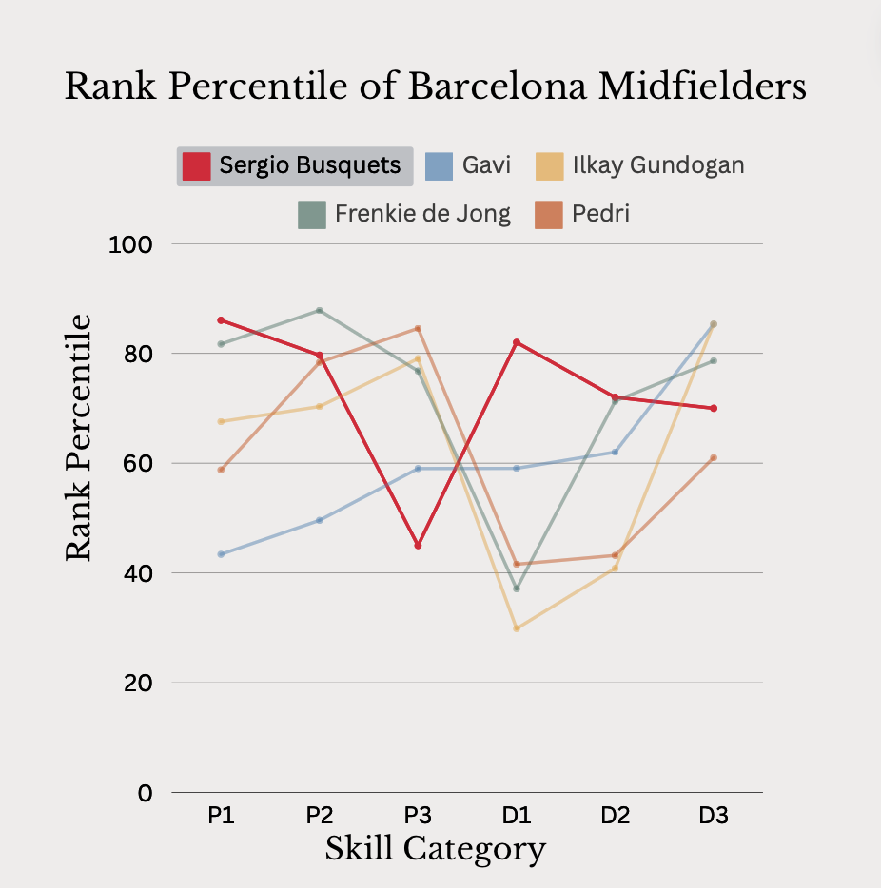

To identify the ideal successor for Sergio Busquets, it is imperative to understand the areas in which he is most indispensable to Barcelona. Hence, we conducted a comparative analysis of his performance against current Barcelona midfielders in the 2022-23 season (note that Gundogan was playing for Manchester City then, before joining Barcelona in the summer of 2023). The values depicted in the line plot represent the percentile ranking of Barcelona midfielders among all midfielders in the top 5 European Leagues for each skill category.

As illustrated by the line plot, Busquets has a starkly distinct profile compared to the current Barcelona midfielders. Notably, he ranks among the top 25% in all but one category, showcasing exceptional prowess in defensive phase progression (P1) and transition defense (D1). Particularly in transition defense, there is a significant gulf in quality between Busquets and his counterparts. Let us delve deeper into analyzing these 2 pivotal categories.

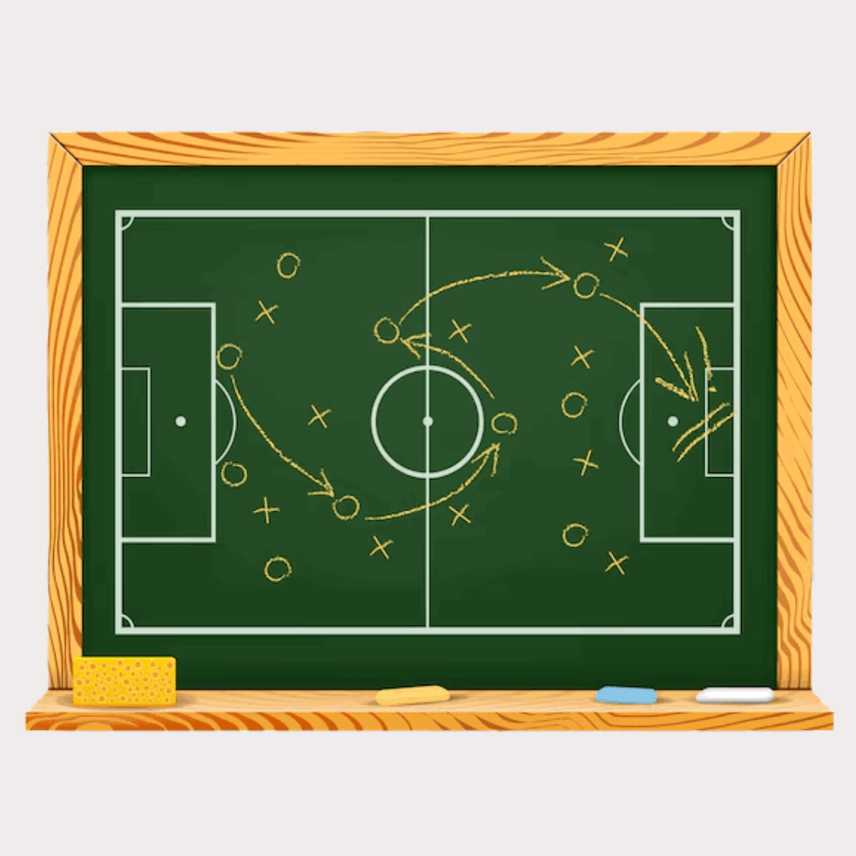

Tiki-Taka [Source: Freepik]

**Defensive Phase Progression:** Barcelona is renowned for their possession-oriented playing style, commonly known as *Tiki-Taka*. Unlike other teams with more direct styles of play, Barcelona teams patiently build out from their own defensive area by finding teammates in space via short, intricate passes. While this approach provides a more systematic and secure way of progressing the ball up the pitch, it also carries inherent risks. Any loss of possession in their own defensive area exposes Barcelona to immediate threats since opponents are positioned dangerously close to Barcelona's goal, which significantly increases the likelihood of conceding.

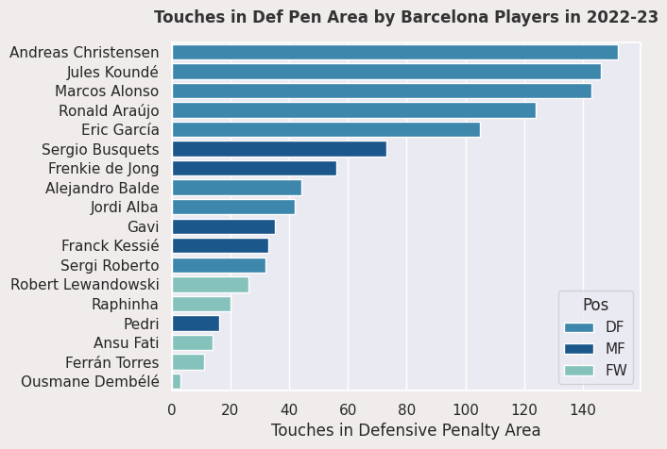

Enter Sergio Busquets, whose irreplaceable value shines in such situations. As seen from the bar chart above, Busquets boasts one of the highest number of touches within Barcelona’s defensive penalty area, second only to the central defenders. This underscores his pivotal role in orchestrating Barcelona’s build-up play from deep within their defensive zone. Frequently the recipient of his goalkeeper’s initial pass, Busquets demonstrates impeccable ball control, ensuring that possession remains secure despite the proximity of his opponents. Following that, with his prompt decision-making abilities, he efficiently initiates Barcelona's build-up play, either with a precise one-touch pass to a teammate in space, or an elegant half-turn to evade opponents’ pressure. While seemingly straightforward, Busquets’ consistent execution of such maneuvers at the highest level against the toughest opponents is what makes him so special. Attempting to steal the ball from Busquets is akin to grabbing smoke with your bare hands, and it is exactly such a calm and secure presence that Barcelona has sorely missed this season. Struggling to build out seamlessly from the back, Barcelona has resorted to pumping long balls which increases the number of turnovers, a lamentable deviation from their revered footballing philosophy.

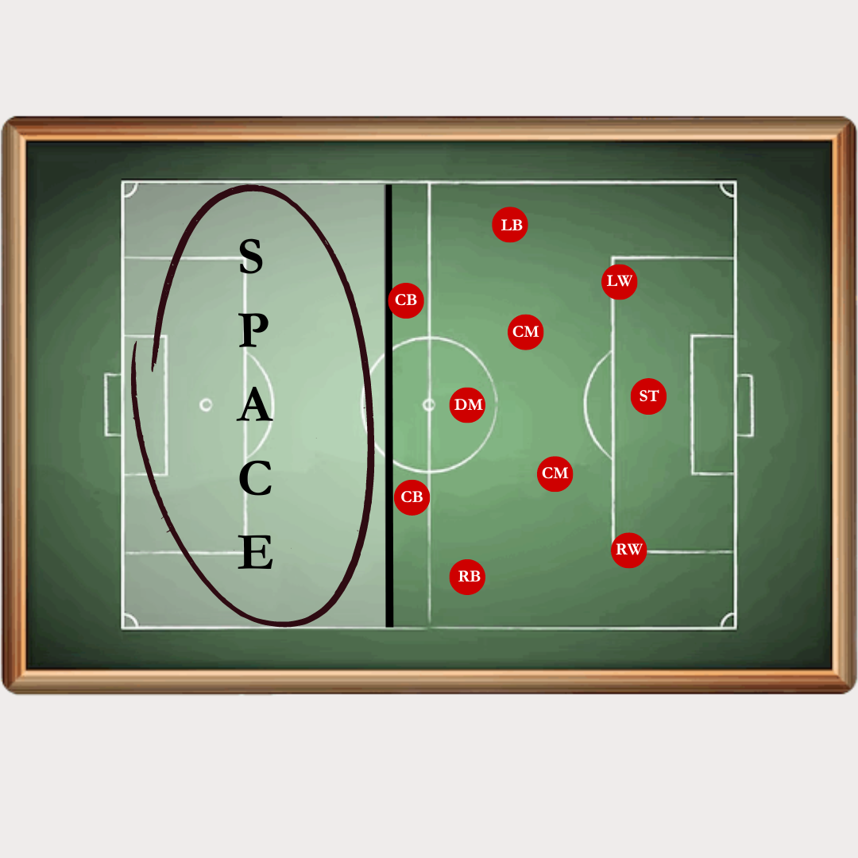

Barcelona’s High Defensive Line [Source: Passion4FM]

**Transition Defense:** Another highlight of Barcelona’s style of play is their high defensive line, with virtually every outfield player in the opponent’s half. This tactic aims to pin opponents back towards their own goal to restrict their space. Yet, as highlighted in the image above, such an aggressive approach leaves acres of space behind Barcelona’s defensive line for opponents to exploit, particularly those with fast, skilful dribblers capable of launching swift counter-attacks. Once they dribble past Barcelona’s defenders, they have a free run at goal. To thwart such threats, it is crucial to nip these counter-attacks in the bud, whether through well-timed tackles or tactical fouls.

Once again, this is Busquets’ expertise. Despite his lack of pace, he often emerges victorious in duels against dribblers. Leveraging his footballing intelligence and wealth of experience to anticipate his opponent’s next move, he executes timely tackles with remarkable success. With a 58.7% success rate in tackling dribblers, Busquets ranks among the top 12% of midfielders in this metric. Even when he fails to win the ball outright, he stalls the dribbler’s progress with calculated fouls, buying precious time for his teammates to retreat and regroup defensively.

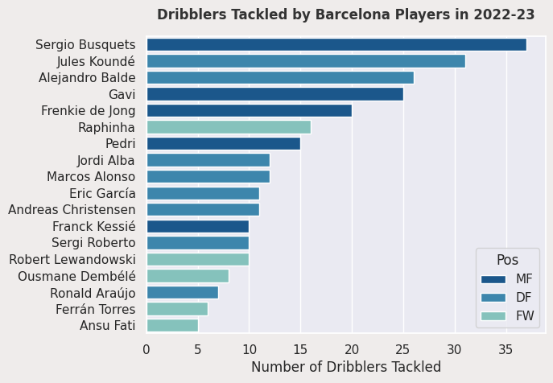

Last season, Busquets led Barcelona players in tackles against dribblers, showcasing his pivotal role in transition defense. Without his commanding presence this season, Barcelona has been the 4th-worst team in La Liga when it comes to expected goals conceded from counter-attacks. They have struggled immensely against teams who defend in a low block, before counter-attacking them with fast-paced dribblers like Granada’s Bryan Zaragoza and Athletic Bilbao’s Nico Williams. While Barcelona's current midfielders excel in ball-carrying and chance creation, they lack an elite ball-winner like Busquets who excels in halting transitions and neutralizing counter-attacks.

**Identifying Potential Successors**

**Methodology:** In our quest to find the ideal successor to Sergio Busquets, it is crucial to identify players with similar strengths as him. Based on our preceding analysis, we selected 34 key metrics in which Sergio Busquets excels, including touches in the defensive penalty area and dribblers tackled. Subsequently, we extracted statistical data from the 2022-23 season for all midfielders across the top 5 European Leagues who played over 1000 minutes, evaluating them against these 34 metrics. For each metric, we standardized the values using a standard normal distribution, before calculating the rank percentile of each midfielder. However, given the high correlation observed among some metrics, such as dribbles tackled and the percentage of dribbles tackled, we need to use dimensionality reduction techniques to combine these highly correlated metrics to reduce redundancy.

The dimensionality reduction technique that we chose is Principal Component Analysis (PCA). The primary objective of PCA is to retain maximal information in the data while minimizing the number of metrics. New, uncorrelated variables, otherwise known as principal components, are constructed from linear combinations of existing metrics to serve as replacements.

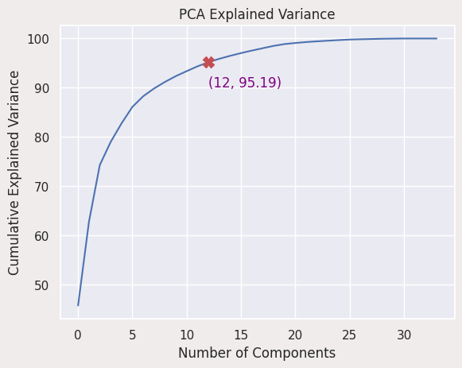

As we introduce additional principal components, we aim to retain more information, or variance, within the data. However, as depicted in the line plot, the cumulative explained variance eventually reaches a point of saturation after a certain number of principal components. Typically, a PCA model capable of capturing 95% of the total variance is deemed satisfactory, which requires 12 principal components for our data. After fitting our data to the PCA model, we have successfully reduced the number of metrics from 34 to 12.

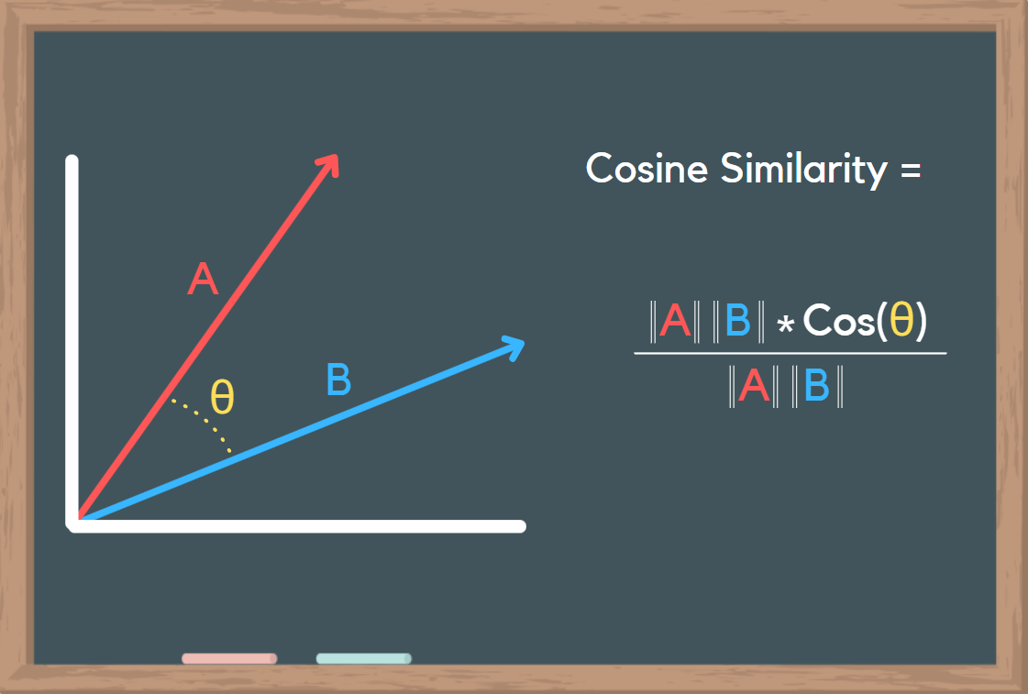

Cosine Similarity [Source: AI-ContentLab]

Now, each midfielder is represented as a numerical vector in a 12-dimensional feature space. To determine the likeness between each pair of midfielders, we utilized the Cosine Similarity algorithm. The image above provides a visual explanation of Cosine Similarity. Given two vectors representing two midfielders, if their Cosine Similarity value is closer to 1, the angle between them is closer to 0 since cos(0) = 1. This indicates that the two vectors, or midfielders, are extremely similar, and vice versa. Based on these similarity scores, we determined the top 15 midfielders that are most similar to Sergio Busquets. Finally, out of these 15, we handpicked 6 of them as our final candidates. For each candidate, we compared their rank percentile in each of the 6 skill categories with Busquets. Subsequently, we rated their age, proneness to injury, and price affordability on a scale of 1 to 5, with 5 being the most desirable.

#1: Thomas Partey

#2: Corentin Tolisso

#3: Jordan Veretout

#4: Rodri

#5: Nemanja Matić

#6: William Carvalho

#7: Toni Kroos

#8: Marco Verratti

#9: Sofyan Amrabat

#10: Enzo Fernández

#11: Frenkie de Jong

#12: Joshua Kimmich

#13: Djibril Sow

#14: Fabián Ruiz Peña

#15: Thiago Mendes

**Candidate 1: Thomas Partey**

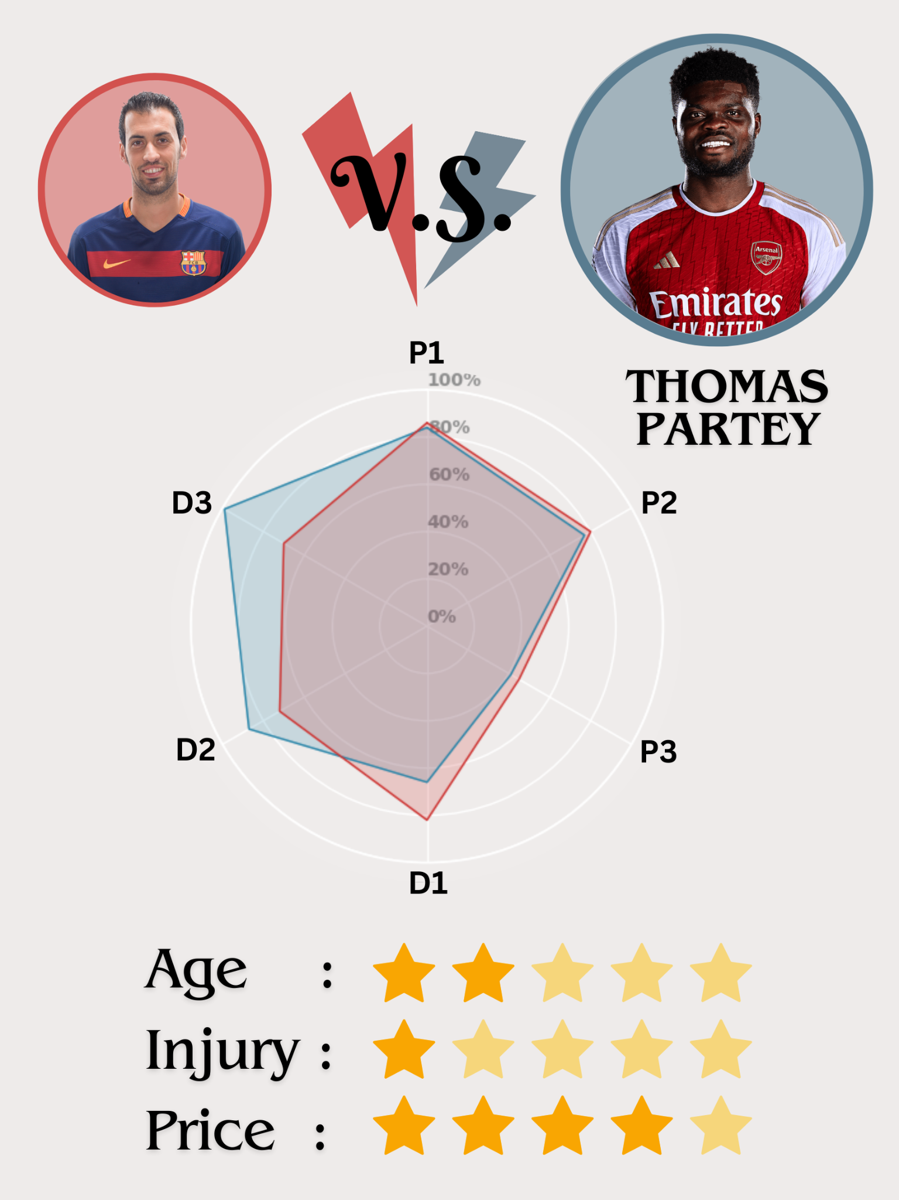

Based on our model, Arsenal’s Thomas Partey is most similar to Sergio Busquets. Renowned as one of the most physically dominant, box-to-box midfielders, he boasts exceptional defensive and offensive prowess coupled with a relentless work rate. Our radar plot shows that he closely mirrors Busquets in terms of his proficiency in ball progression, but they differ slightly in defensive styles. As an elite ball-winner (D2), Partey excels at high-intensity pressing further up the field (D3), which is contrary to Busquets, who tends to sit deeper at the base of the midfield.

However, Partey’s aggressive playing style does not align with Barcelona’s ideal profile. The club desires a more composed presence that can dictate the tempo of possession and be the anchor in transition defense. Partey is also entering his 30s and missed 70% of Arsenal’s games this season due to injuries. Given Barcelona's need for reliability and longevity in their squad, acquiring an injury-prone player poses substantial risk. Therefore, considering both tactical and physical factors, Thomas Partey may not be the best choice for Barcelona.

**Candidate 2: Rodri**

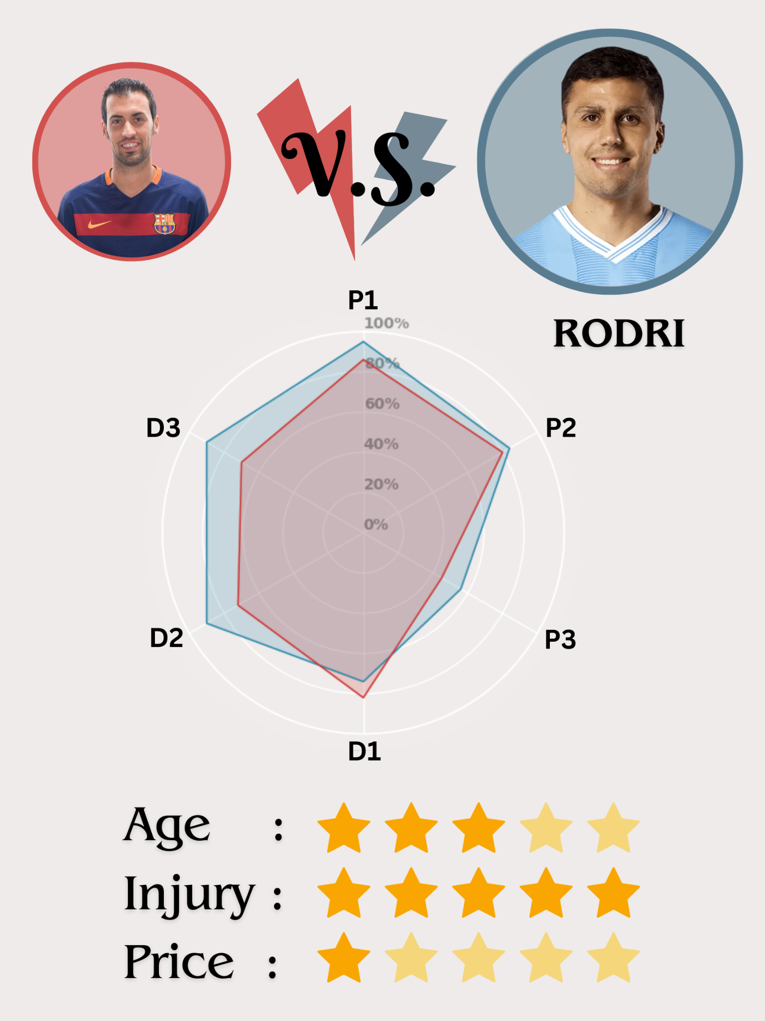

Widely regarded as the best defensive midfielder in the world right now, Rodri excels in almost all facets of the game, ranking among the top 10% in defensive 3rd progression (P1), ball-winning (D2), and high press (D3). Similar to Busquets, he excels in P1 and D1, so he can comfortably inherit Busquets’ role at Barcelona. More impressively, he surpasses Busquets in 5 of the 6 skill categories, indicating his potential to elevate Barcelona’s midfield to new heights.

Rodri has been identified by Busquets himself as his ideal successor. With his tactical acumen, technical prowess, physical dominance, and reliability on and off the pitch, Rodri seems to be precisely what Barcelona needs. Unfortunately, we all know this transfer is too good to be true. At 27, Rodri is at the peak of his career, playing for the reigning UCL champion under one of the greatest managers in football history. It is hard to fathom Manchester City breaking up their winning formula; and even if they were to consider an offer for Rodri, his €110 million market value is way beyond Barcelona's financial reach.

**Candidate 3: William Carvalho**

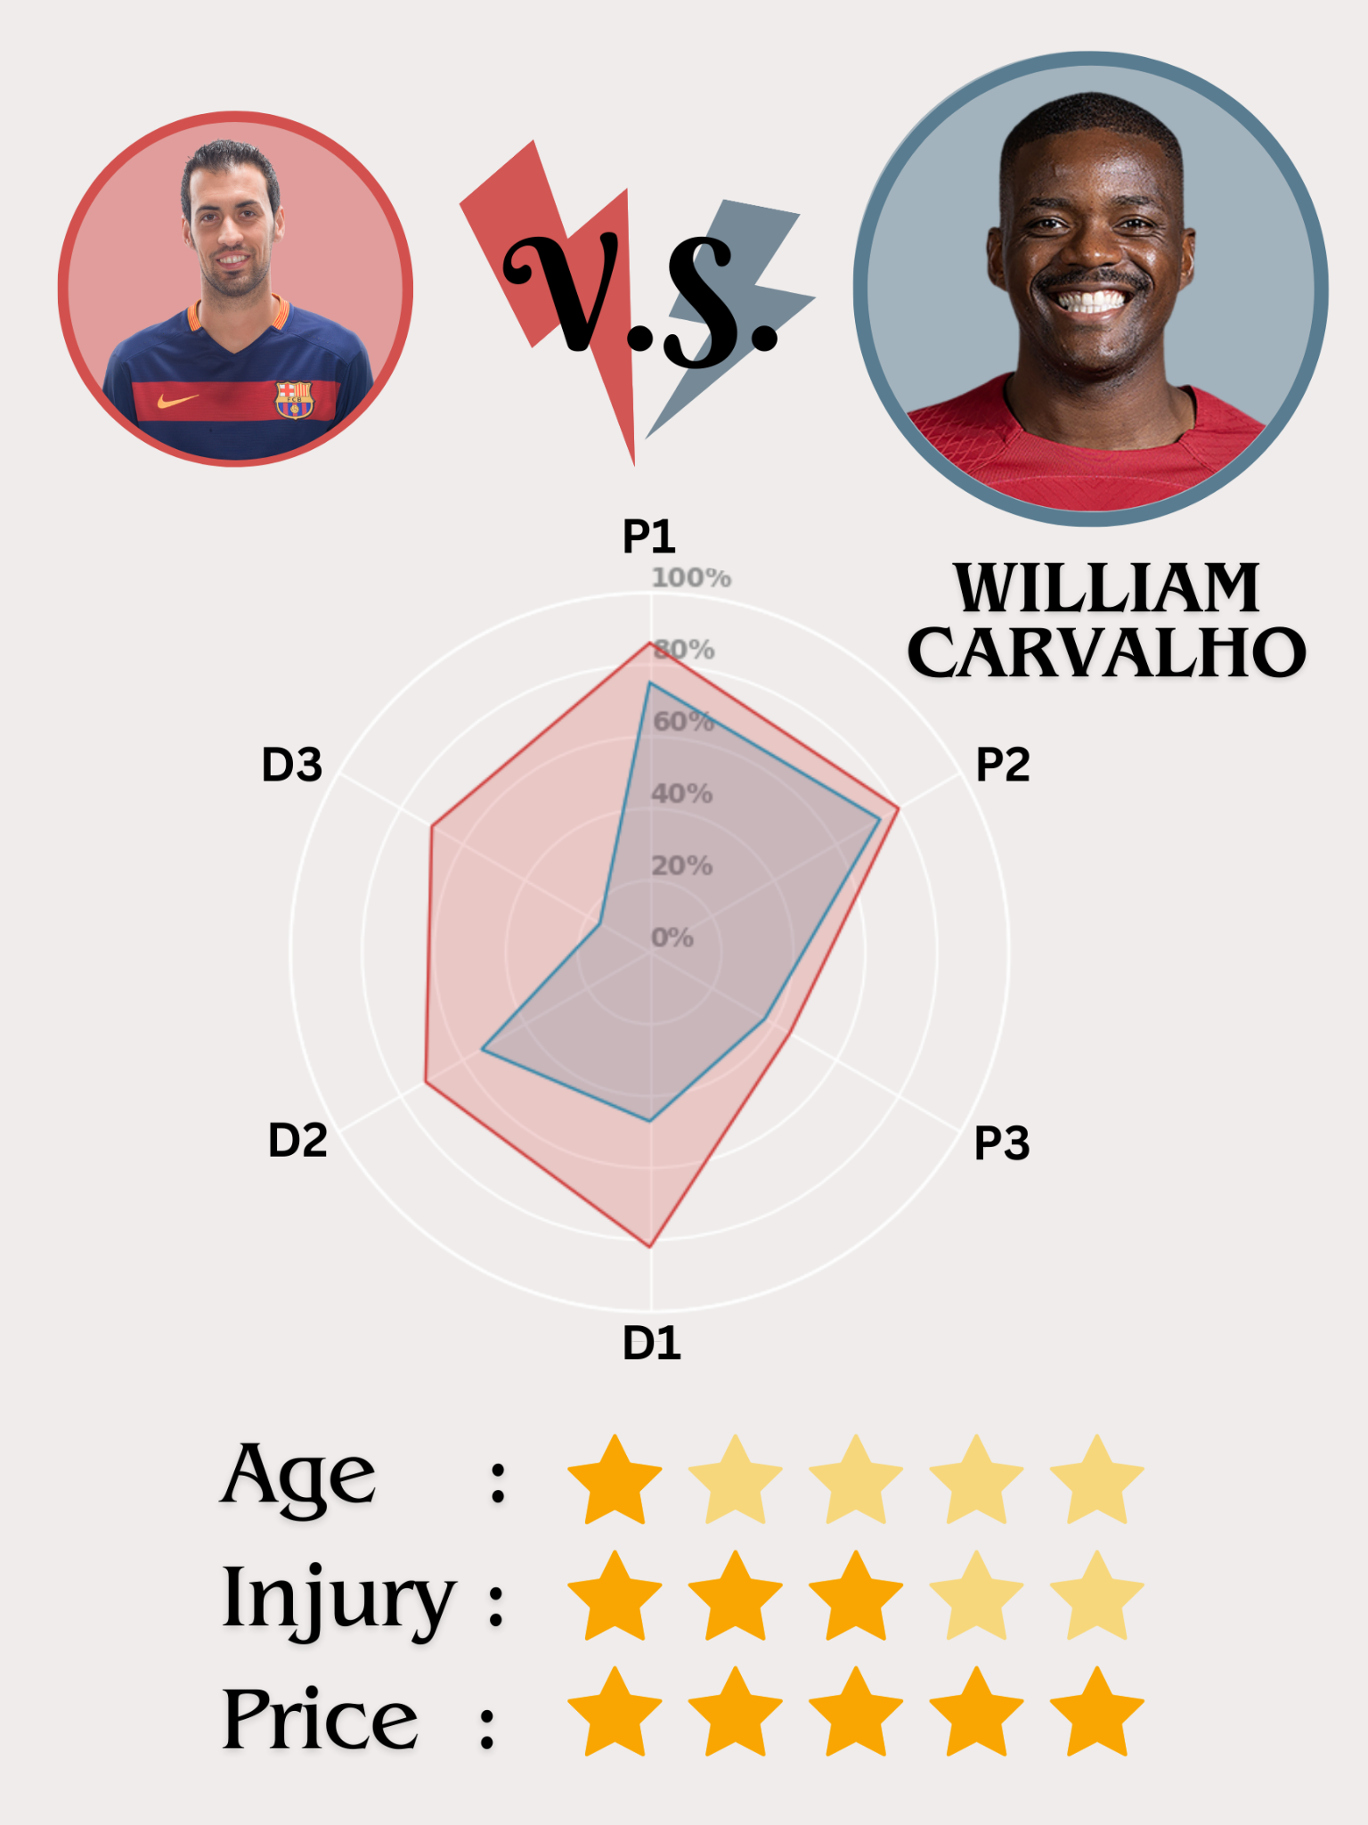

Playing pivotal roles in both Portugal’s triumph in Euro 2016 and Real Betis’ recent resurgence, William Carvalho is one of the most underrated defensive midfielders. Similar to Busquets, he compensates for his lack of pace with his imposing physicality, astute decision-making, and flawless passing.

Yet, despite being on par with Busquets in ball progression, his defensive prowess falls significantly short. His performance in transition defense (D1) is worse than the average midfielder. Since Barcelona has been suffering the most in transition defense after Busquets’ departure, Carvalho may not be the ideal solution. Nevertheless, Carvalho has a modest market value of $5 million. Thus, Barcelona could consider him as a short-term, low-cost replacement for Busquets who has loads of experience in La Liga.

**Candidate 4: Sofyan Amrabat**

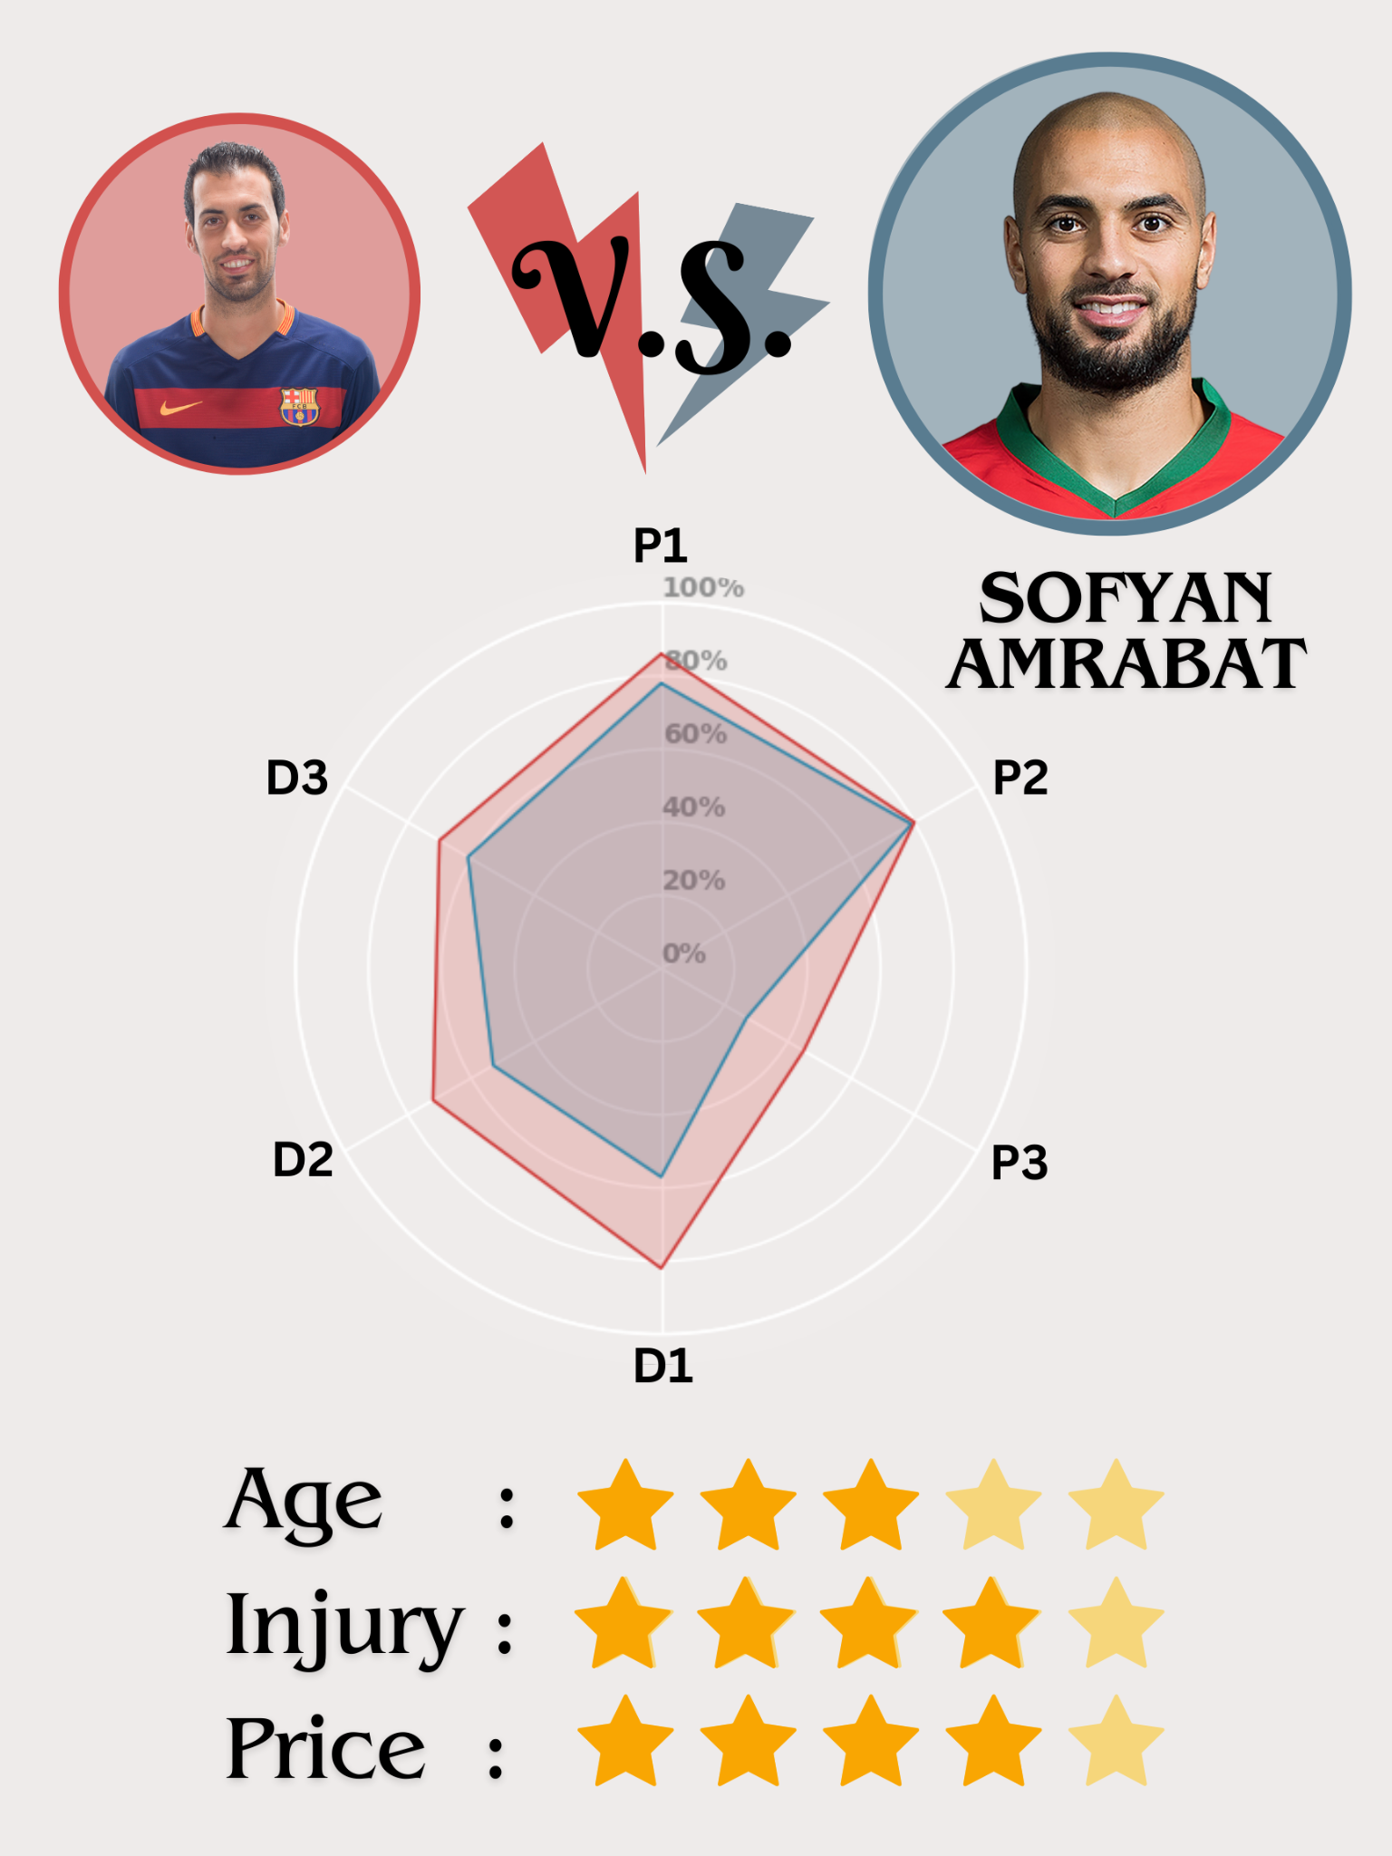

Having led Morocco to a 4th-place finish, Sofyan Amrabat's outstanding performance in the recent World Cup captured interest from a host of top-tier European clubs, including Barcelona. Just like Busquets, Amrabat is an elite ball-winner and progressor who tends to drop deep between the center-backs to orchestrate play from the back. While his D1 score seems low due to fewer dribblers tackled, his success rate in tackling dribblers places him among the top 15% of midfielders, mirroring Busquets' proficiency in this category.

However, after joining Man United on loan this season, he has been struggling for consistency. The pressure of playing for a big club seems to be taking a toll on his confidence. It is rumored that Man United has no interest in signing Amrabat on a permanent deal, which presents Barcelona with an opportunity to secure his services for a mere $15 million. Barcelona could reap bountiful returns off a bargain price if they manage to restore Amrabat’s confidence. Yet, with sky-high expectations from fans who demand players to compete at the highest level, time is not a luxury at Barcelona. Therefore, the club may lean towards acquiring a proven winner who thrives under pressure.

**Candidate 5: Enzo Fernandez**

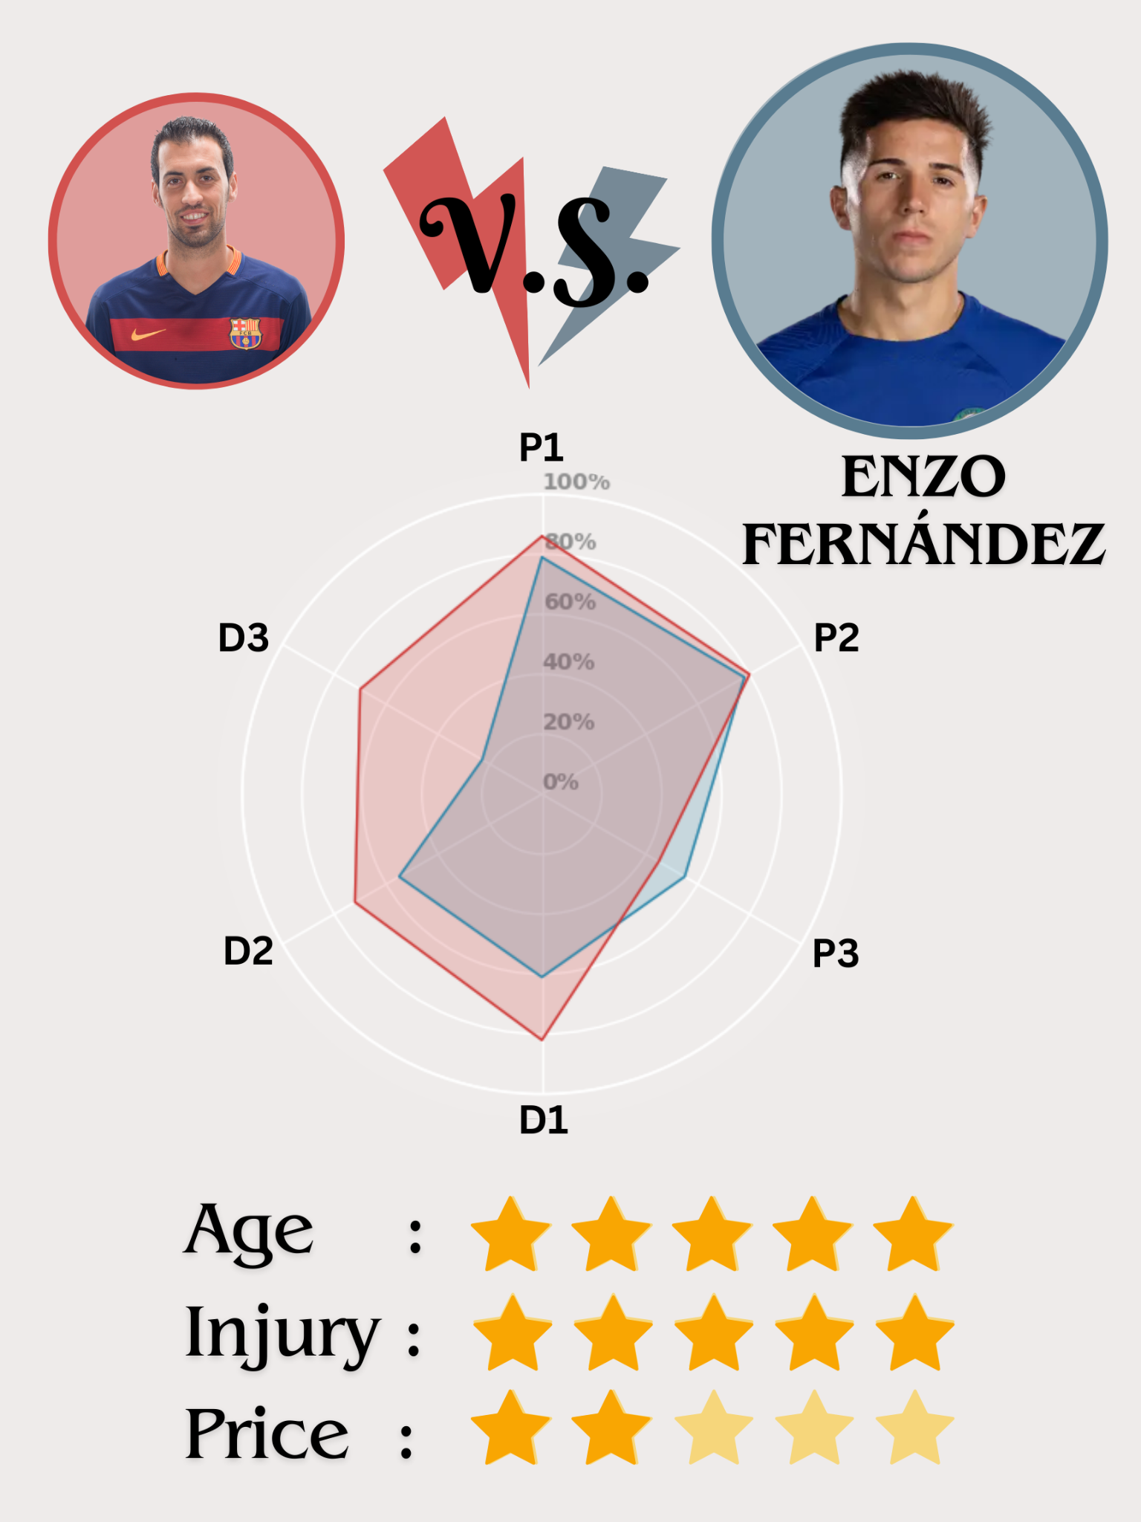

Enzo Fernandez took the world by storm after his startlingly impressive 2022 World Cup campaign, as he played an integral role in Argentina’s eventual triumph. Enzo possesses a range of weapons in his arsenal – wide passing range, incredible close control of the ball, and intelligent off-the-ball movements – which makes him extremely press-resistant. (Does this remind you of someone?) Furthermore, he is tenacious in duels, as his energy and agility facilitate swift directional changes when fighting for loose balls. Defensively, he adopts a more conservative approach, preferring to cover the spaces vacated by teammates rather than pressing high up the pitch. Overall, Enzo fits closely to Barcelona’s desired profile.

At 23, Enzo is poised for sustained success at the elite level. Unfortunately, his recent commitment to an eight-year contract with Chelsea until 2031 is an insurmountable obstacle to any potential Barcelona bid. Given his indispensable value to Chelsea, it is highly unlikely that they will agree to his sale. It is worth keeping an eye on Enzo’s development though. If Barcelona’s finances recover and Chelsea continues to underwhelm, there’s a chance we might see Enzo following the footsteps of his idol, Lionel Messi.

**Candidate 6: Joshua Kimmich**

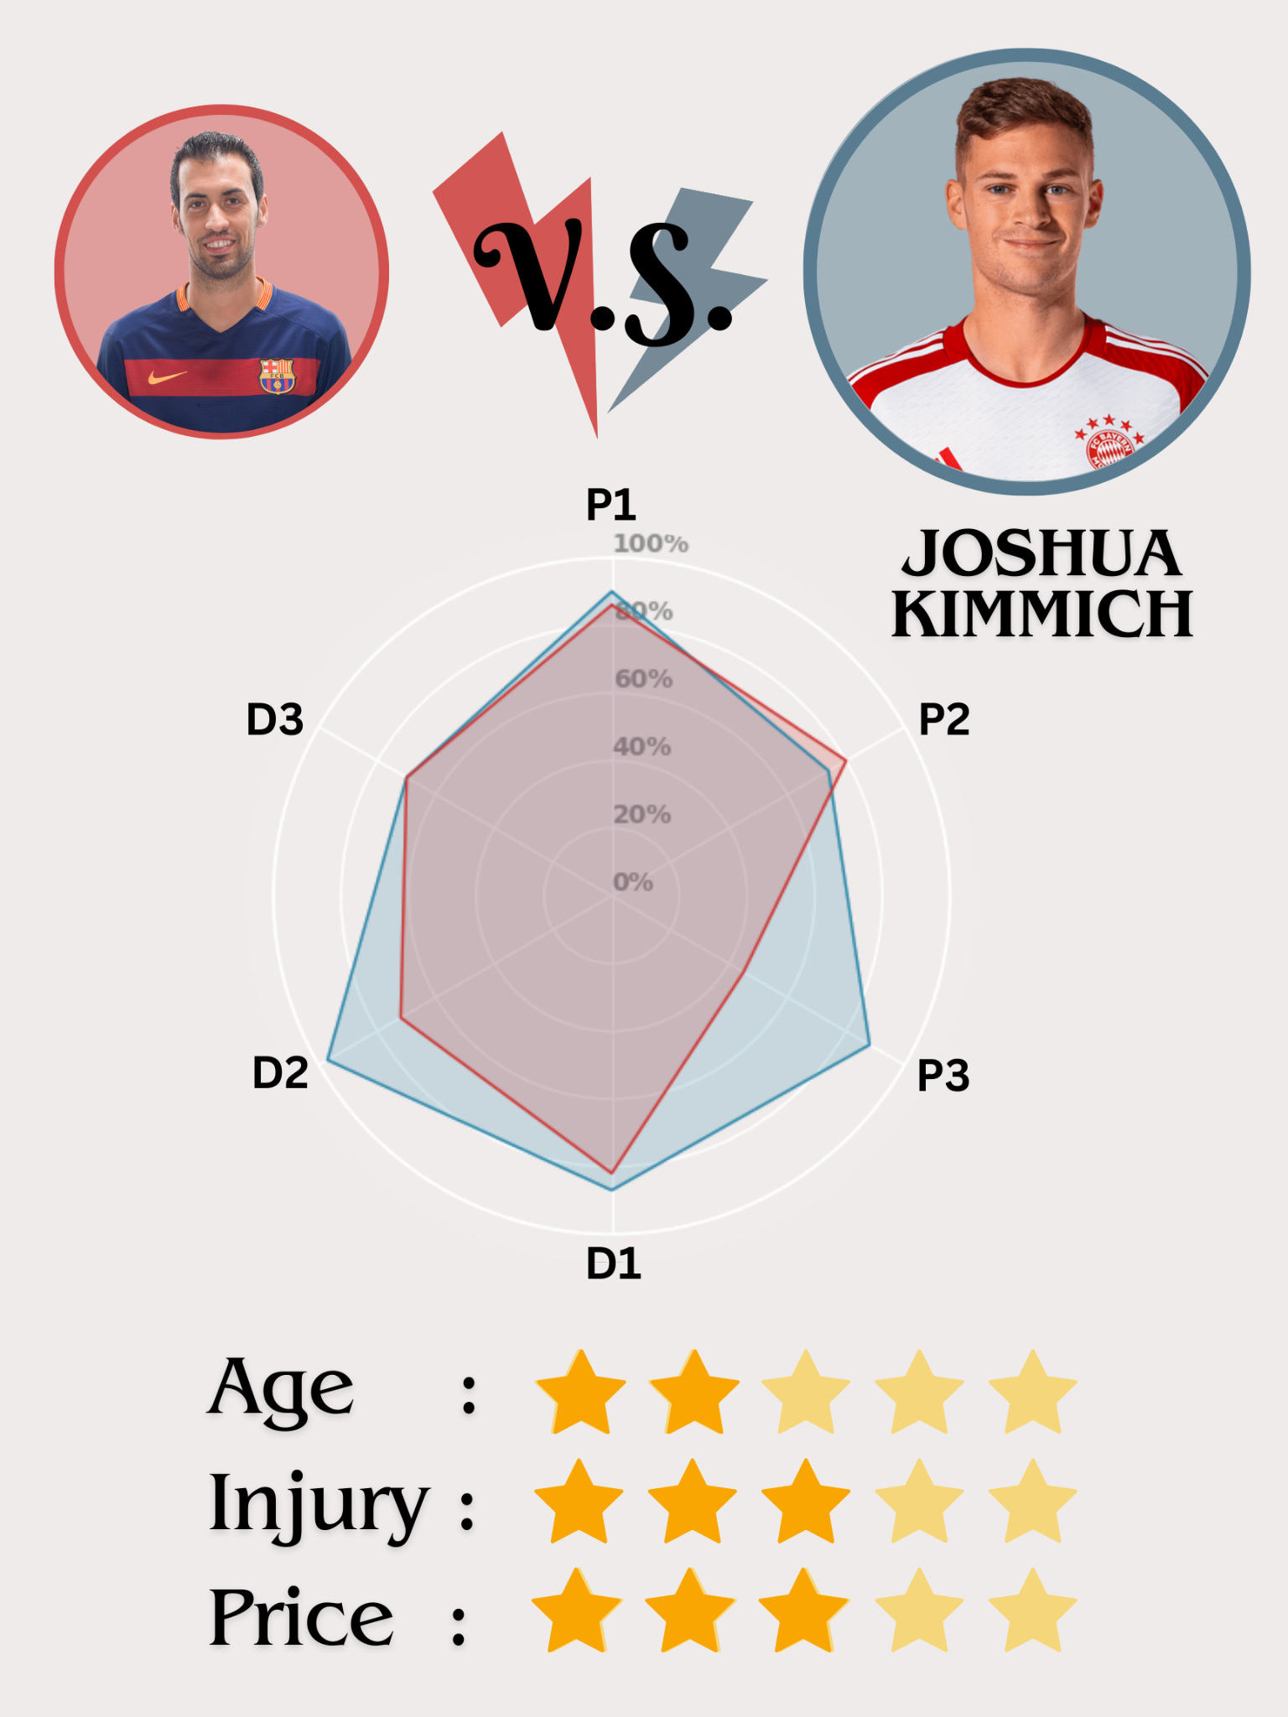

An integral cog of the indomitable Bayern machine, Joshua Kimmich has performed consistently at the highest level for the past decade. Like Rodri, he embodies the archetype of a world-class defensive midfielder, boasting superior statistics than Busquets in all but one skill category. Kimmich’s greatest strength is his unshakeable composure – even under intense pressure near his own goal, he rarely loses the ball and often delivers accurate forward passes. Furthermore, Kimmich’s astute spatial awareness enables him to defend effectively despite Bayern’s high defensive line, as he understands when to press the opponent (D3) and when to hold position (D1). Kimmich’s qualities shine brightest in a double pivot alongside a creative, attack-minded midfielder. His past success with Thiago shows that he could thrive in a similar role at Barcelona alongside Frenkie de Jong.

Approaching his thirties, Kimmich's athletic prowess may be waning. Yet, with loads of experience under his belt, Kimmich will still be able to provide world-class quality as long as Barcelona plays to his strengths. Most importantly, with just one year remaining in his Bayern contract, his market value of $50 million falls within Barcelona's financial reach. Therefore, he is an enticing option as Busquets’ ideal successor in the short term.

**Conclusion & Final Choice**

In today’s football landscape where prolific goalscorers and flamboyant dribblers often dominate the headlines, Sergio Busquets serves as a humble reminder of the beauty of simplicity. As a custodian of Barcelona’s footballing philosophy, Busquets epitomizes the essence of *tiki-taka* with his quick passing, fluid movements, and astute understanding of time and space. As his influence often goes under the radar, it is only after his departure that many Barcelona fans begin to appreciate his value, especially in orchestrating build-up play from the back and stifling opposition transitions and counter-attacks. Without an adequate replacement for the maestro, Barcelona has been struggling to fill the gaping hole in their midfield, resorting to makeshift solutions like deploying center-back Christensen out of position. Thus, finding the ideal heir to Busquets is Barcelona’s top priority in the upcoming summer transfer window.

Among the 6 final candidates that we have selected using our model, Joshua Kimmich emerges as our prime choice. Not only is he a world-class midfielder who excels in all skill categories, his style of play fits perfectly with Barcelona’s footballing philosophy. Moreover, unlike Rodri and Enzo Fernandez, Kimmich’s price tag is within the financial reach of cash-strapped Barcelona. Most importantly, Kimmich is a serial winner who thrives under pressure on the grandest stages, so Barcelona can be rest assured that he will deliver instant success to the team. However, if Barcelona cannot afford to sign Kimmich, viable short-term alternatives such as Sofyan Amrabat and William Carvalho are also worth considering.

Beyond our 6-man shortlist, there are many more talented defensive midfielders who have been overlooked by our model. One notable omission is Martin Zubimendi, an emerging talent who has been likened to both Busquets and Rodri. This could be due to our choice of metrics when building the model; if we had used a different set of metrics, our final candidates would have been slightly different. In addition, our model only takes into account established midfielders in Europe’s top five leagues. Hence, budding talents in the Dutch Eredivisie and the Portuguese Primeira Liga, such as Feyenoord’s Mats Wieffer, have been excluded in our analysis. Keep an eye on Barcelona’s academy prospects too, especially Pau Prim, who is hailed as the next Sergio Busquets for his adeptness in passing and defensive acumen.

Sergio Busquets’ has drawn the curtains on his illustrious career in Barcelona. While we look back fondly on the joy and successes he has brought to the club, it is time to look ahead and plan for the future. Bolstered by once-in-a-generation talents like Lamine Yamal and Pau Cubarsi, Barcelona stands on the cusp of greatness. Acquiring a world-class defensive midfielder is the final jigsaw piece needed to propel Barcelona back to the pinnacle of world football once again.

**Acknowledgements**

We wish to express our sincerest gratitude to Rose Yang, Jimmy Hou and Lionel Hu for their invaluable insights and advice.

**References**

“2022-2023 Big 5 European Leagues Stats (Players).” *FBref.Com*, fbref.com/en/comps/Big5/2022-2023/stats/players/2022-2023-Big-5-European-Leagues-Stats. Accessed 3 Mar. 2024.

“Football/Soccer Session (Beginner): Thirds of the Field.” *Sport Session Planner*, www.sportsessionplanner.com/s/TrZg/Thirds-of-the-field.html. Accessed 30 Mar. 2024.

May 08, 2023, et al. “Understanding Cosine Similarity and Its Role in Machine Learning.” *AI*, www.ai-contentlab.com/2023/05/understanding-cosine-similarity-and-its.html. Accessed 31 Mar. 2024.

“Soccer Board Images - Free Download on Freepik.” *Freepik*, www.freepik.com/free-photos-vectors/soccer-board. Accessed 25 Mar. 2024.

“Tactical Analysis of the Barcelona Tiki Taka Playing Style • Passion4fm.Com.” *Passion4FM*, 22 Feb. 2023, www.passion4fm.com/tactical-analysis-of-the-barcelona-tiki-taka-playing-style/.

Varun. “Rebuilding Man Utd’s Midfield: Part 1 – Profiles, Tasks & Gaps.” *Thedevilsdna.Com - A New Era Is Upon Us*, 26 Feb. 2024, thedevilsdna.com/?p=273944.